Task 1: -List 3 real-world devices in your home or college that use SMPS (Switched Mode Power Supply) and 2 devices that use UPS (Uninterruptible Power Supply), explaining in one line why each device needs that type of power supply.
A. Three devices that use SMPS (Switched Mode Power Supply)
No. | Device | Why it needs SMPS
1 | Laptop | Converts electrical power into regulated DC power for charging the battery and operating the laptop efficiently.
2 | Desktop Computer | Supplies stable DC power to the motherboard, CPU, RAM, graphics card, and storage devices.
3 | Wi-Fi Router | Converts AC power from its adapter into low-voltage DC power required for continuous operation.

B. Two devices that use UPS (Uninterruptible Power Supply)
No. | Device | Why it needs UPS
1 | Desktop Computer | Provides temporary backup power during a power cut, allowing the user to save work and shut down safely.
2 | Wi-Fi Router | Maintains internet connectivity during a power outage, provided the modem and other network equipment also have power.

2) Draw and label a diagram showing the main internal components of a typical SMPS unit found in a desktop PC, including AC input, rectifier, transformer, and DC output sections. You can hand-draw and upload a photo, or use any free diagram tool like draw.io.
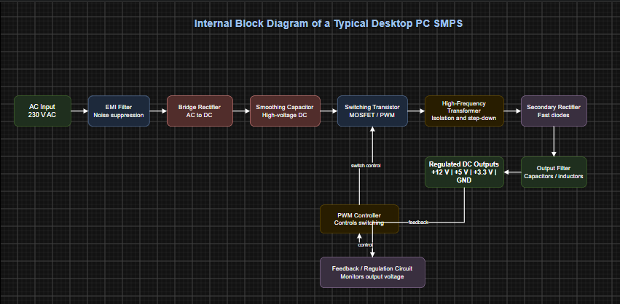

3) Take photos or find clear images online of the following power connectors: ATX 24-pin motherboard connector, SATA power connector, Molex connector, and PCIe 6/8-pin connector. For each, write its name, the devices it powers, and one safety tip for connecting/disconnecting it.
PC Power Connectors: Identification, Uses, and Safety
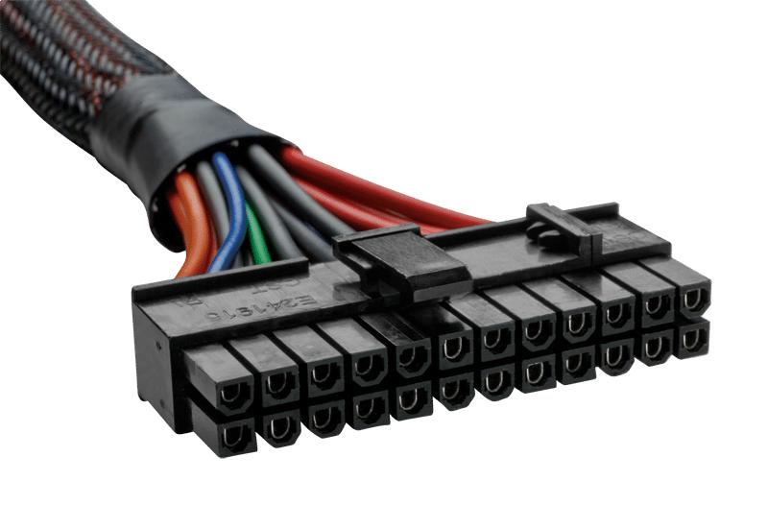
1. ATX 24-pin motherboard connector

- Name: ATX 24-pin motherboard power connector (often 20+4 pin).
- Devices it powers: Supplies the main power rails to the motherboard, which distributes power to components and circuits.
- Safety tip: Switch off and unplug the PC before connecting or disconnecting. Align the clip with the socket and ensure it locks into place.
2. SATA power connector
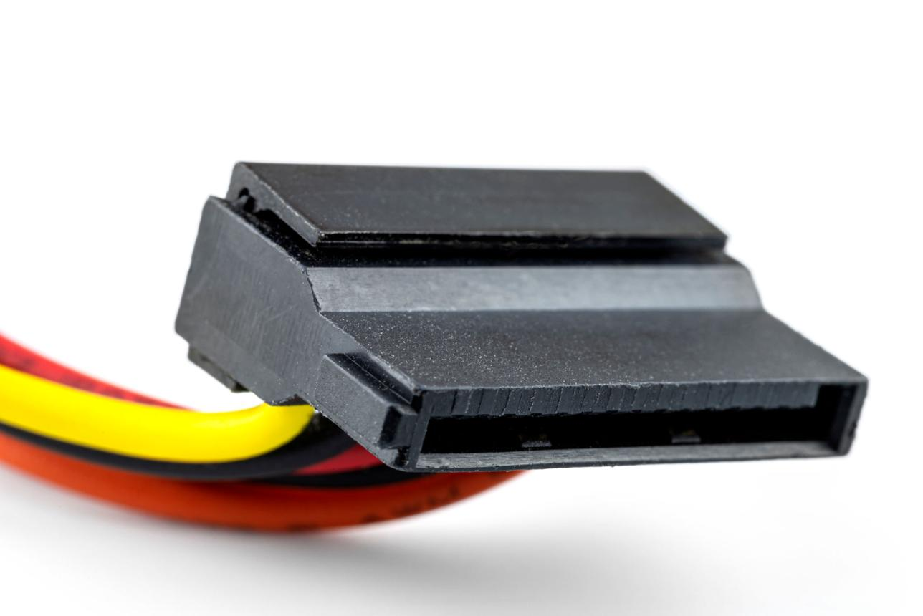
- Name: SATA 15-pin power connector.
- Devices it powers: SATA hard disk drives (HDDs), SATA solid-state drives (SSDs), and compatible optical drives.
- Safety tip: Align the L-shaped connector correctly and insert it gently. Never force it into the socket.

3. Molex 4-pin peripheral connector
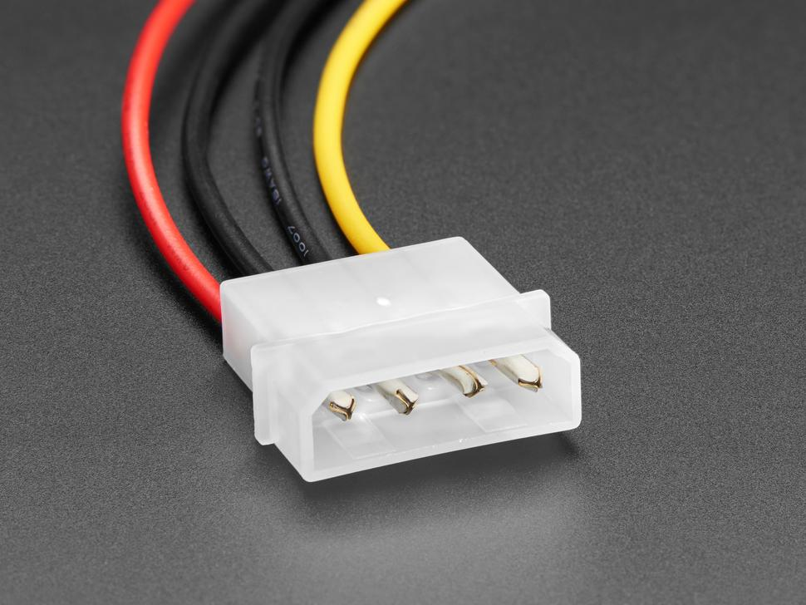
- Name: Molex 4-pin peripheral power connector.
- Devices it powers: Older hard drives, CD/DVD drives, some case fans, and other compatible peripherals.
- Safety tip: Turn off and unplug the PC, then grip the plastic connector housing when removing it. Do not pull on the wires.
4. PCIe 6-pin/8-pin graphics card connector
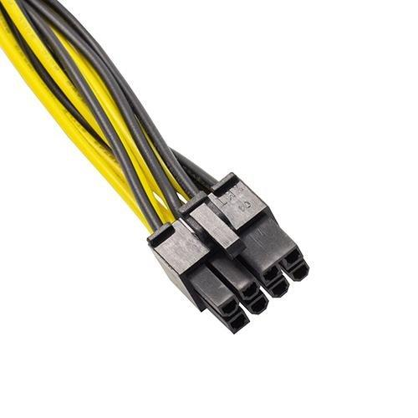
- Name: PCIe 6-pin or 8-pin (6+2-pin) power connector.
- Devices it powers: Compatible dedicated graphics cards (GPUs) that require additional power from the PSU.
- Safety tip: Use the correct cable labelled PCIe or GPU, not the similar-looking CPU/EPS cable. Ensure the connector is fully inserted and latched.
Connector | Main device powered | Key safety tip
ATX 24-pin | Motherboard | Align the latch and ensure it locks.
SATA power | HDD, SATA SSD, optical drive | Match the L-shaped key; never force it.
Molex 4-pin | Older drives and compatible fans | Grip the housing, not the wires.
PCIe 6/8-pin | Dedicated graphics card | Use the correct GPU cable and check the latch.

4) Imagine you are setting up a new gaming PC. List the steps you would follow to connect the SMPS to the motherboard, graphics card, and storage devices, mentioning which specific cables and connectors are used for each.
Steps to Connect an SMPS in a New Gaming PC
1. Install the SMPS: Mount the power supply inside the computer cabinet and secure it with screws.
2. Connect the motherboard: Use the 24-pin ATX power connector to supply the main power to the motherboard.
3. Connect the CPU: Use the 4+4-pin EPS/CPU power connector to provide dedicated power to the processor through the motherboard.
4. Connect the graphics card: Use the required PCIe 6-pin, 8-pin, or 12V-2x6 power connector, depending on the graphics card model.
5. Connect storage devices: Use a 15-pin SATA power connector to supply power to SATA hard disk drives (HDDs) and solid-state drives (SSDs). Connect a separate SATA data cable between each drive and the motherboard.
6. Check all connections: Ensure that all power connectors are properly inserted and secured. Arrange the cables neatly to maintain proper airflow inside the cabinet.
7. Start the computer: Close the cabinet, connect the AC power cable, switch on the SMPS, and start the computer to verify that all components work correctly.

